HOME EQUITY LOAN DECISION MAKING ANALYTICS

Project Introduction
The Consumer Credit Division of a regional bank aims to improve its home equity loan process. In recent years, the bank has seen an increase in loan volume growth. However, it has also seen an increase in delinquency rates and the volatility of net charge-offs. This, in addition to the rise of fintech companies providing instant loan decisions, made the previous underwriting process unsustainable.
At present, the bank’s loan approvals are based on a combination of established bank standards and underwriter judgment. This caused problems with consistency in loan approval standards and operational efficiency issues. As a solution, the bank has come up with a project to build a data-driven credit scoring model to standardize loan decisions, improve risk assessment, and ensure transparency aligns with the Equal Credit Opportunity Act (ECOA) requirements, which state that if an adverse credit action is taken, it must have clear and specific reasons.

Business and Analytical Goal

Business Goal
The primary business goal is to improve the identification of borrowers who are likely to default while maintaining a balanced approach to loan approvals. The system should help the bank reduce credit risk, improve consistency in decision-making, and remain competitive by enabling faster approvals.
In addition, the model should provide clear and explainable reasons for credit decisions to ensure compliance with regulatory requirements. The bank aims to balance risk reduction with continued loan growth, rather than focusing only on minimizing defaults.

Analytical Goal
The main analytical objective is to develop an interpretable model that predicts whether a borrower will become a bad borrower (BAD = 1).
To support this objective:
Classification modeling is used as the primary approach to estimate the probability of default and support approve/decline decisions.
Clustering analysis is used to identify borrower segments with different risk profiles and to provide additional business insights.
Regression analysis is used to study relationships related to leverage (such as loan-to-value) and understand financial exposure patterns.
These approaches are used to support decision-making, but the final credit decision is driven by the classification model.

Data Preprocessing
The dataset provided by the bank has 5960 rows and 13 variables. Each row represents a borrower, and each variable represents the financial and credit characteristics of the respective borrower. No duplicate records detected in the dataset.

Attribute Definition:
- BAD:
This is a binary variable (0,1). Where 0 indicates not a bad borrower and 1 indicates a bad borrower. This is the target variable with distribution of 4,771 0’s and 1,189 1’s.
- LOAN:
LOAN is the loan amount approved by the bank ranging from$1,100 to $89,900 with a median value of $16,300.
- MORTDUE:
It is the mortgage amount due (outstanding balance) by the borrower to the bank. Ranging from $2,063 to $399,550 with median value of $65,019. This variable has 518 missing values in the dataset which is 8.7% of total records.
- VALUE:
VALUE is the property value in dollars on which the loan is borrowed. This ranges from $8,000 to $855,909 with median value of $89,236. This variable has 112 missing records in the dataset which is around 1.8% of the total records.
- REASON:
This is a categorical variable which tells the reason for loan as stated by borrower. It has two major reasons “Home Imp.” (Home improvement) and “DebtCon” (Debt Consildation). There were 1,780 loans taken under Home Improvement reason and 3928 loans under debt consolidation reason. This variable has 252 blanks or missing values.
- JOB:
JOB is also a categorical variable which describes the occupation of the borrower. There are 6 types of occupations which include Mgr (767), Office (948), Other (2388), ProfExe (1276), Sales (109), Self (193) and 279 blanks / missing values.
- YOJ:
YOJ is a numeric variable which tells how many years the borrower has been working at the current job. Ranging from 0 to 41 years with 8.9 years average and 515 missing values.
- DEROG:
DEROG is number of derogatory marks on the borrower at the time of loan approval. This ranges from 1 to 10 with 708 missing values. Majority of the borrowers have 0 derogatory marks.
- DELINQ:
DELINQ is the number of credit lines that the borrower was delinquent at the time loan approval. This ranges from 0 to 15 with 580 missing vaues.
- CLAGE:
This variable is the number of months the borrower has an oldest credit line at the time of loan approval. This ranges from 0 to 1,168 months with 179 average months and 308 missing values.
- NINQ:
NINQ is the number of credit line enquiries on the borrower in recent past. This number ranges from 0 to 17 with 1 as the median value and 510 missing values.
- CLNO:
CLNO is the number of credit lines the borrower has on record (open / closed) when the loan was approved. This ranges from 0 to 71 with 20 as the median and 222 missing values.
- DEBTINC:
This is the ratio of the borrower’s total debt to income at the time of approval. This ranges from 0.5 to 203.31 with 34.82 as median value and 1267 missing records.
The data set provided has a lot of missing values in most of the columns. Overall, around 41% of the data is missing from the dataset out of which only BAD, LOAN columns have no missing values.

Exploratory Data Analysis:
The target variable BAD is a binary variable its distribution is discussed below,
Out of the total of 5,960 loan accounts in the dataset, 4,771 (80.1%) are current, while 1,189 (19.9%) are defaulted or seriously defaulted.
The class balance in this dataset is moderately unbalanced, with the minority class (BAD = 1) comprising about one in five cases.
The class balance in this dataset has direct implications on model evaluation. The class imbalance should be considered during model development and evaluation.
A summary of key differences between BAD = 0 and BAD = 1 groups, based on a comparative analysis of key variables, is as follows:
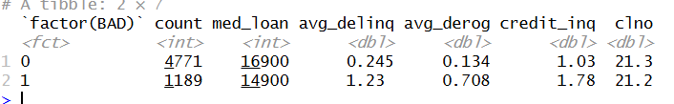
From these differences, it is evident that bad borrowers had a lower median loan amount of $14,900 as opposed to $16,900 for good borrowers. The most notable differences are in the credit behavior, with the average number of delinquent credit lines per bad borrower being 1.23, compared to 0.245 per current borrower, which means that active delinquency is strongly concentrated in the default group. Similarly, the average number of derogatory reports per bad borrower was 0.708, compared to 0.134 per current borrower, indicating DEROG and DELINQ as the strongest individual risk signals. The average credit inquiries per bad borrower were slightly higher (1.78 vs 1.03), which may indicate greater recent credit-seeking activity in the default group.
The continuous variables in the dataset (LOAN, MORTDUE, VALUE, YOJ, CLAGE, and DEBTINC) were examined using summary statistics and distribution plots.
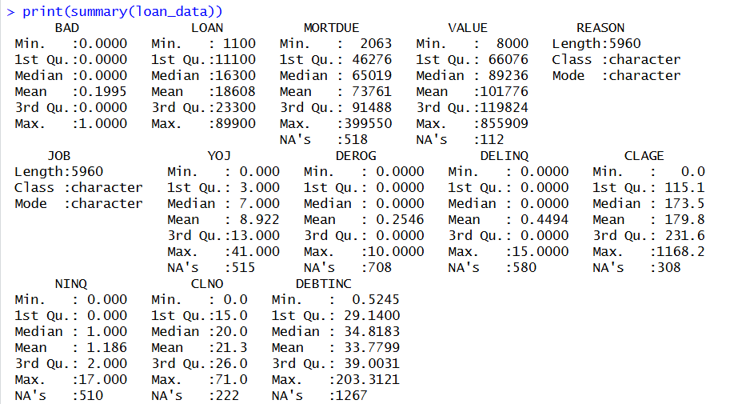
All financial variables, including LOAN, MORTDUE, and VALUE, demonstrated right-skewed distributions, which align with the presence of smaller loan amounts and property values. MORTDUE and VALUE had the largest range, with maximum values of $399,550 and $855,909, respectively, signifying high variability in existing mortgage amounts and property values.
The DEBTINC variable demonstrated the most alarming data distribution issue, with a maximum value of 203.3%. It is extremely rare for a functioning borrower to have a 100%+ debt-to-income ratio, as this means their total debt obligations exceed their gross income. Also, for CLAGE there are some unusual values like 1,168 which means a credit line with age of around 97 years. Similarly, the YOJ value has 41 years of current job which is very rare. These types of values are likely the result of data entry errors and are likely extreme outlier values, which should be addressed.
DEROG, DELINQ, NINQ, and CLNO are discrete variables and are heavily concentrated at zero or low values as expected because most of the borrowers of a bank will have minimal credit history if they are on its approved list. The BAD rate was calculated for each of the values of DEROG, DELINQ, and NINQ.
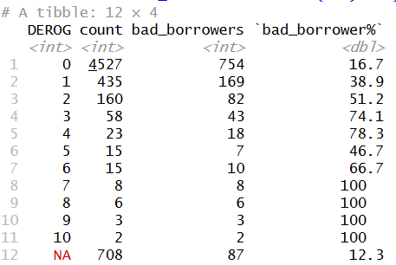
For the group with zero derogatory reports, the BAD rate was 16.7%. The BAD rate increased sharply for every additional derogatory report, rising to 38.9% for one, 51.2% for two, and 74.1% for three. The groups with seven or more derogatory reports had a default rate of 100%, but these groups are very small in size.

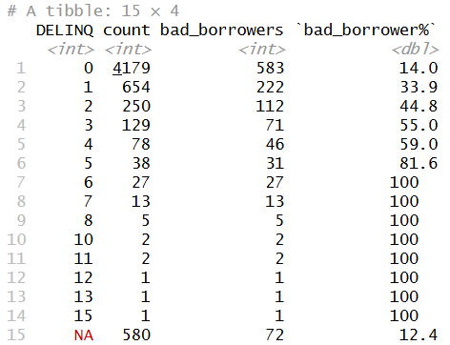
The relationship between DELINQ and default risk was even more dramatic. The BAD rate started at 14.0% for those with zero delinquent credit lines, escalated to 33.9% for those with one, 44.8% for those with two, 55.0% for those with three, and reached 100% for those with six or more.
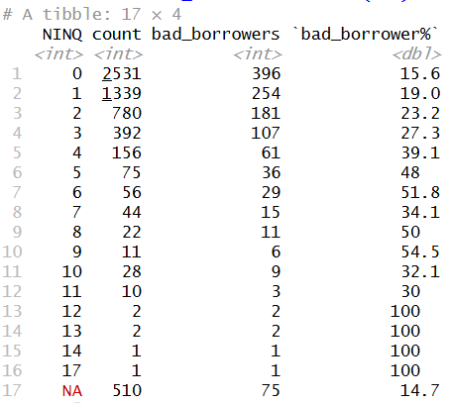
NINQ had a generally increasing pattern with default risk, although not as smooth as the DEROG and DELINQ relationships. Those with no inquiries had a 15.6% BAD rate, which increased steadily to 19.0% at one, 23.2% at two, and 39.1% at four. However, the pattern became erratic at higher numbers of inquiries because of small sample sizes.
REASON and JOB are the two categorical variables. Distribution analysis is done on both these variables as below
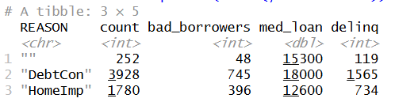
Majority of loans in the dataset were taken to consolidate debts (DebtCon: 3,928 loans, 65.9%), compared to home improvement (HomeImp: 1,780 loans, 29.9%), with 252 loans having missing values in the REASON variable. Debt consolidation loans had a higher median loan amount of $18,000 compared to home improvement loans, which had a median loan amount of $12,600. In addition, the number of loans that were delinquent was higher in the debt consolidation group compared to the home improvement group, although this may be because the debt consolidation group was larger in terms of number of loans.
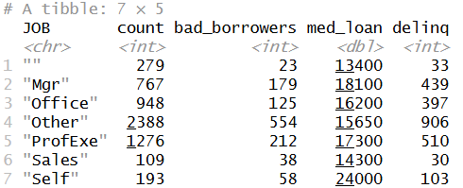
The most prevalent category in the JOB column was "Other" with 2,388 borrowers (40.1%), followed by "ProfExe" with 1,276 borrowers (21.4%), "Office" with 948 borrowers (15.9%), "Mgr" with 767 borrowers (12.9%), "Self" with 193 borrowers (3.2%), "Sales" with 109 borrowers (1.8%), and 279 records with missing values in the "JOB" column. The category "Self" reported the highest median amount for the loan at $24,000. This aligns with the higher equity draw that self-employed individuals tend to exhibit. The categories "Sales" and "Other" reported the highest number of bad borrowers.

Correlation Analysis:
A correlation matrix was computed across all numeric variables to assess linear relationships among predictors and with the target variable BAD. The most notable findings are summarized below
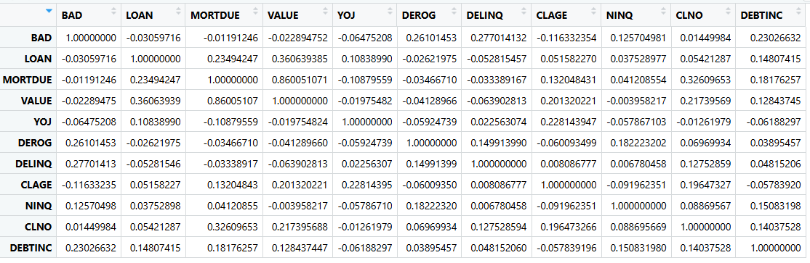
DEROG and DELINQ also displayed the highest positive correlations with BAD at 0.261 and 0.277 respectively. DEBTINC and NINQ also displayed positive correlations with BAD at 0.230 and 0.126 respectively, while CLAGE displayed a negative correlation of -0.116, reinforcing the notion that borrowers with longer credit histories have lower default rates. LOAN, MORTDUE, and VALUE displayed near-zero correlations with BAD individually.
A strong correlation was identified in the relationship between MORTDUE and VALUE, as this pair had a very high correlation of 0.860. This makes sense, as properties with higher market values will have more existing mortgage balances.

Outlier and Anomaly Detection:
Outliers were identified using the three standard deviation rule, flagging values exceeding the mean plus three standard deviations as extreme. The output below summarizes the findings across all continuous variables.
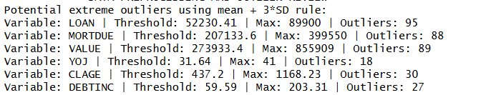
LOAN, MORTDUE, and VALUE had approximately 88 to 95 extreme values at 1.6%. These are extremely high but plausible in real estate lending. YOJ and CLAGE had very few extreme values at 18 and 30, respectively, that represented legitimate long employment and good credit histories. These should not be capped as they accurately characterize the borrower. Therefore, they were left unchanged.
But there are couple of values with extremely high CLAGE (1168.2 and 1154.6). These records are inspected and found that there are no credit lines (CLNO). Which indicates these may be data entry errors.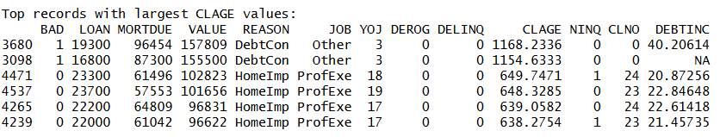
The CLAGE values are looked at where the CLNO is 0. Which reveals that all the values for CLAGE are NA’s when CLNO is 0. Since CLNO = 0 indicates no active credit lines, CLAGE is not meaningful in those cases. Therefore, these two observations were treated consistently by assigning CLAGE = 0.

Handling Missing Values:
Missing values were identified across nine of the thirteen variables prior to modeling.
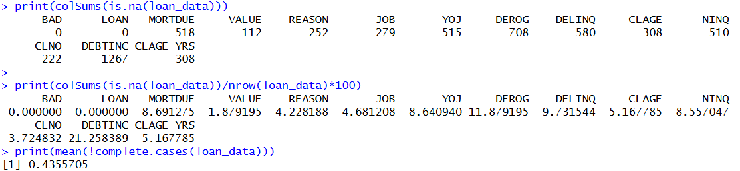
The pattern analysis of the missing data indicated that 59% of the data, which comprised 3,515 cases, had complete data, while the remaining 41% had missing data in varying combinations. Missing values were identified across eleven of the thirteen variables, with DEBTINC exhibiting the highest rate at 21.3% (1,267 records), followed by DEROG at 11.9% (708 records) and DELINQ at 9.7% (580 records).
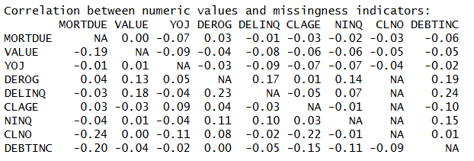
The correlation between the data using the shadow matrix indicated borrowers who had lower property values had more missing data in their MORTDUE and DEBTINC, and borrowers who had fewer credit lines had more missing data in their CLAGE.

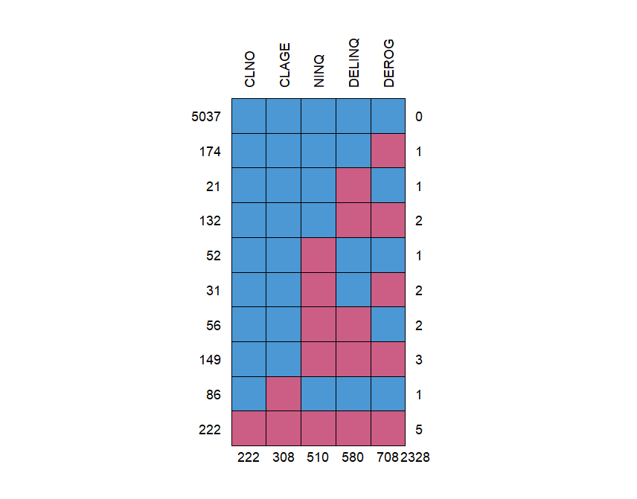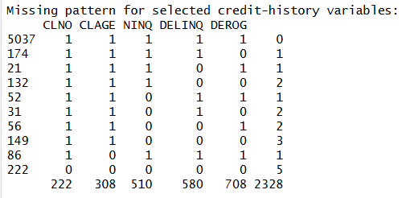

A missing pattern of 222 records where five variables missing together is identified. Missingness across credit variables such as DEROG, DELINQ, NINQ, and CLNO appears to occur jointly, indicating structured missingness rather than completely random absence. These five variables (CLNO, CLAGE, NINQ, DELINQ, DEROG) are related to credit history which suggests that there no credit history for these borrowers which is usually termed as “Thin File” customers in banking. This can be used as potential new variable which may influence prediction.
Miss Forest imputation was used for all the remaining variables containing missing data, including the categorical variables REASON and JOB. missForest imputation is based on an iterative random forest algorithm, which predicts missing values using all the variables in the data set. This imputation technique was chosen over listwise deletion and mean substitution, both of which are biased for MAR, and over k-nearest neighbor imputation, which is appropriate for smaller sample sizes and not for larger sample sizes.
The dataset is split into train and test before imputation and imputation model trained and imputed on the train dataset is also used on the test dataset. The results of the imputed train dataset is analyzed and evaluated by comparing it with original dataset (train set before imputation).
The plot above shows the boxplots of all the variables before and after the imputation. The imputation results in almost same distribution for most of the variables which indicates the missForest imputation has done a good job. Furthermore, the correlations between the variables are analyzed after the imputation.
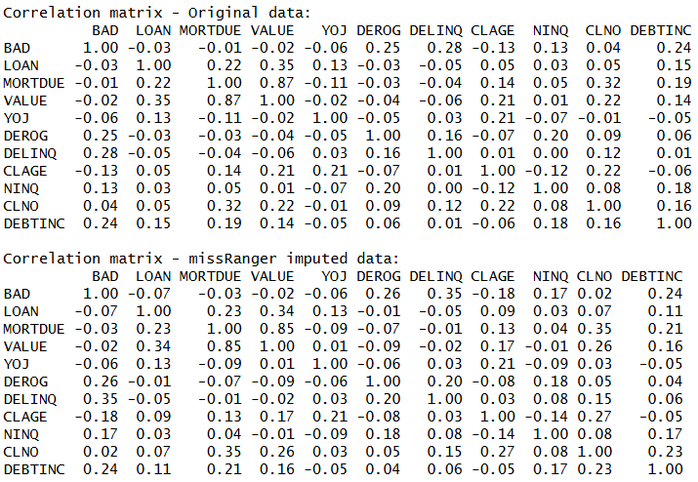
The correlations of the original and imputed dataset has not been changed drastically. The imputation maintains the correlation between the variables almost same with slight increase in some variables which is expected.

Predictor Analysis and Variable Relevance
Target Variable: BAD
The main outcome variable for this project is BAD. This variable identifies whether a borrower stayed current or became a bad borrower. In the dataset, BAD = 0 means the borrower remained current, and BAD = 1 means the borrower defaulted or became seriously delinquent. The dataset has 5,960 loan records, with 4,771 current borrowers and 1,189 bad borrowers. This means 80.05% of borrowers are current and 19.95% are bad borrowers.
This distribution shows that the data is imbalanced. Most borrowers are current, while only about one out of five borrowers is in the bad borrower group. This is important because the bank’s main business problem is not only to predict the majority group, but to correctly identify borrowers who are more likely to default. Because of this, variables that help separate bad borrowers from current borrowers are especially important.
Credit History Variables
The strongest risk signals came from the borrower’s credit history variables. These include DELINQ, DEROG, NINQ, CLAGE, and CLNO. In the R analysis, these variables were reviewed through default-rate summaries, group comparisons, and correlation analysis.
DELINQ, which represents the number of delinquent credit lines, showed one of the strongest relationships with default. Borrowers with zero delinquent credit lines had a BAD rate of 14.0%. The BAD rate increased to 33.9% for borrowers with one delinquent credit line, 44.8% for two, 55.0% for three, and 59.0% for four. For borrowers with six or more delinquent credit lines, the BAD rate reached 100%, although those groups were small.
This pattern makes DELINQ highly relevant because it directly reflects recent credit repayment problems. In the correlation analysis, DELINQ also had one of the highest positive correlations with BAD, around 0.28 in the original data and 0.32 after imputation.
DEROG, which represents major derogatory credit reports, also showed a strong relationship with default. Borrowers with zero derogatory reports had a BAD rate of 16.7%. This increased to 38.9% for one derogatory report, 51.2% for two, and 74.1% for three. Borrowers with very high derogatory counts had very high default rates, but those categories had small record counts, so they should be interpreted carefully.
NINQ, which measures recent credit inquiries, also showed a rising default pattern. Borrowers with zero inquiries had a BAD rate of 15.6%. This increased to 19.0% for one inquiry, 23.2% for two, 27.3% for three, and 39.1% for four. The pattern became less stable at higher values because fewer borrowers were present in those groups. Still, the overall result suggests that borrowers with more recent credit inquiries may carry higher risk.
CLAGE, the age of the oldest credit line, had a negative relationship with default. Its correlation with BAD was about -0.12 in the original correlation analysis and about -0.17 after imputation. This means borrowers with longer credit histories were generally less likely to become bad borrowers. This is reasonable because a longer credit record gives the bank more evidence of borrower stability.
CLNO, which represents the number of credit lines, had a weak direct relationship with BAD. Its correlation with the target was close to zero. However, it was still useful in the workflow because it helped identify unusual and missing credit-history patterns. For example, the missing value review found 222 records where CLNO, CLAGE, NINQ, DEROG, and DELINQ were missing together. This supported the creation of the MISS_CRED_INFO variable during preprocessing.
Debt Burden and Repayment Capacity
DEBTINC, the debt-to-income ratio, was another important predictor. It measures the borrower’s debt burden compared with income. In the original correlation matrix, DEBTINC had a positive correlation with BAD of about 0.23. After imputation, the correlation was still positive at about 0.16.
This means borrowers with higher debt obligations were more likely to become bad borrowers. This variable is important for the bank because repayment capacity is a direct part of credit decision-making. However, DEBTINC also had the highest missing-value rate in the dataset, with 1,267 missing records, or 21.26%. Because of this, it was treated carefully during the missing-value handling process before being used in later analysis.
Loan and Property Variables
The loan and property-related variables include LOAN, MORTDUE, and VALUE. These variables describe the size of the loan, the borrower’s existing mortgage balance, and the property value.
In the correlation analysis, these variables had weak direct relationships with BAD. LOAN had a correlation of about -0.03 with BAD, MORTDUE had about -0.01, and VALUE had about -0.02. This shows that loan size or property value alone did not strongly separate current borrowers from bad borrowers.
However, these variables are still relevant to the business problem because home equity lending depends on collateral and borrower exposure. The project requirement explains that a home equity loan is secured by borrower equity in the property, so loan size, property value, and existing mortgage obligations are important for understanding risk exposure.
The analysis also found a very strong relationship between MORTDUE and VALUE. Their correlation was about 0.86 in the original data and 0.85 after imputation. This means these two variables carry overlapping information. In simple terms, borrowers with higher-value properties often also have higher mortgage balances. This relationship was important to note because it can affect later model behavior.
Employment and Borrower Profile Variables
YOJ, or years on current job, showed a weak negative relationship with BAD. Its correlation with BAD was about -0.06. This suggests that borrowers with longer job tenure were slightly less likely to default, but the relationship was not as strong as credit-history variables such as DELINQ and DEROG.
JOB was reviewed as a categorical borrower profile variable. The largest job category was Other, with 2,388 borrowers. This was followed by ProfExe with 1,276 borrowers, Office with 948, Mgr with 767, Self with 193, and Sales with 109. The Other group had 554 bad borrowers, while the Sales group had 38 bad borrowers out of only 109 borrowers. The Self group had the highest median loan amount at $24,000.
These results show that job category provides useful borrower context, but it should not be treated as the main risk driver by itself. It is more useful when combined with credit history, debt burden, and collateral-related variables.
Loan Purpose Variable
REASON explains why the borrower requested the loan. The two main loan reasons were debt consolidation and home improvement. Debt consolidation was the larger group, with 3,928 loans, while home improvement had 1,780 loans. There were also 252 missing values before imputation.
Debt consolidation loans had a median loan amount of $18,000, while home improvement loans had a median loan amount of $12,600. Debt consolidation also had 745 bad borrowers, compared with 396 bad borrowers in the home improvement group. Since the debt consolidation group is much larger, the number of bad borrowers should not be judged alone, but the variable is still useful because loan purpose helps describe the borrower’s financial situation.
Missing Credit Information Variable
During the R workflow, a new variable called MISS_CRED_INFO was created to capture borrowers with missing credit-history information. This was based on the missing-value pattern where 222 records had missing values across CLNO, CLAGE, NINQ, DEROG, and DELINQ. These variables are all related to credit history, so the missingness appeared structured rather than random.
This variable was relevant because missing credit history may itself contain risk information. In banking, borrowers with limited credit information are often treated differently because there is less evidence available to judge repayment behavior. Creating this indicator allowed the analysis to preserve that information instead of losing it during imputation.
Summary of Relevant Predictors
The most relevant predictors from the analysis were DELINQ, DEROG, DEBTINC, NINQ, and CLAGE. These variables showed the clearest connection with borrower default behavior. DELINQ and DEROG were especially important because default rates increased sharply as their values increased.
LOAN, MORTDUE, and VALUE had weak direct correlations with default, but they remained useful because they describe loan exposure and collateral. MORTDUE and VALUE were strongly correlated, which showed that they carry similar financial information. JOB and REASON added borrower context, while MISS_CRED_INFO captured a meaningful credit-history missingness pattern.
Overall, the predictor analysis showed that borrower credit behavior and debt burden were more useful for identifying default risk than loan amount alone. This supports the bank’s need for a credit scoring process that is explainable, consistent, and based on clear borrower risk signals.

Dimension Reduction
Methods for reducing dimensions formally, such as PCA, were not used in this case. This is because the banking organization is faced with a practical task, requiring an obvious and understandable credit decision-making process. According to the requirement of this project, one of the important criteria is interpretability since it is necessary to provide a reasonable explanation for any credit decision, especially when refusing to provide financing to customers.
A method such as PCA makes it possible to reduce the number of variables, but at the same time, it will combine existing variables to form a new component. This is problematic for explaining to the credit committee why the decision was made in a particular way. For instance, it might be challenging to tell a customer that his or her loan application was rejected based on a mathematically created component of several variables.
Correlation analysis was used as the main method to identify possible redundancy among numeric variables. The correlation matrix showed that MORTDUE and VALUE were strongly related, while most other predictor relationships were moderate or weak. This helped confirm that broad automatic reduction was not needed.
The target relationships were also reviewed during this process. DELINQ, DEROG, DEBTINC, and NINQ had positive relationships with BAD, while CLAGE had a negative relationship. These variables were kept because they added direct risk information and were easy to explain. Variables such as LOAN, MORTDUE, and VALUE had weak direct correlation with BAD, but they still helped describe loan exposure and collateral, which are important in home equity lending.
Instead of removing many variables, a balanced approach was used. Keep original variables to preserve information, use derived variables like Loan to Value (LTV) to reduce redundancy, allow models to determine which variables are most useful. The only major overlap identified was between MORTDUE and VALUE, and this was addressed through review, interpretation, and the creation of the LTV variable.
This approach maintains interpretability while still improving the quality of the input data.

Data Engineering and Transformation
After the missing values, anomalies, and predictor relationships were reviewed, the next step was to prepare the data into a format that could be used for clustering, regression, and classification. The original dataset had both numeric and categorical variables. The categorical variables were REASON and JOB.
Dummy Encoding for Categorical Variables
Before transformation, blank values in REASON and JOB were changed to missing values. This was needed because blank strings should not be treated as valid categories. After the blank values were handled, both variables were converted into factor format so they could be used correctly in the later modeling process.
The categorical variables JOB and REASON were converted into dummy variables. This was needed because several modeling methods require numeric inputs. The dummy encoding created separate indicator variables for job categories and loan reason while removing the original categorical columns.
For JOB, the workflow created dummy variables such as JOB_Office, JOB_Other, JOB_ProfExe, JOB_Sales, and JOB_Self. For REASON, the workflow created REASON_HomeImp. One category was left out as the reference category to avoid unnecessary duplication.
Creating the Missing Credit Information Indicator
The missing-value review showed that some credit-history variables were missing together. Specifically, 222 records had missing information across credit-related fields such as CLNO, CLAGE, NINQ, DEROG, and DELINQ. Since all of these variables relate to credit history, this pattern was treated as meaningful and not ignored.
To preserve this information, a new variable called MISS_CRED_INFO was created. This variable identifies borrowers whose credit-history information was missing together. In the full dataset, 5,738 borrowers were coded as not missing this combined credit information, while 222 borrowers were coded as having missing credit information.
This transformation was useful because missing credit history can carry business meaning. For a bank, a borrower with limited or unavailable credit-history information may need different risk treatment from a borrower with a complete credit record. Creating this variable allowed the analysis to keep that signal instead of losing it during imputation.
Imputing Missing Values
The dataset had missing values in many fields, especially DEBTINC, DEROG, DELINQ, MORTDUE, YOJ, and NINQ. DEBTINC had the highest missingness, with 1,267 missing records, or 21.26% of the full dataset.
The R workflow used missRanger (missForest) imputation to complete the missing values. This method was applied after the train-test split, so the imputation process was first learned from the training data and then applied to the test data. This avoided using information from the test data while preparing the training data.
Creating the LTV Variable
A new variable called LTV was created to represent loan-to-value. This variable was calculated using the loan amount and property value. It helps summarize how large the loan is compared with the value of the property.
In the training data, LTV had a minimum value of 0.015, a first quartile of 0.122, a median of 0.169, a mean of 0.215, a third quartile of 0.242, and a maximum of 1.76.
This transformation was useful because home equity lending depends heavily on collateral and leverage. LTV gives the bank a simple way to understand how much exposure exists relative to the property value. The correlation review showed that LTV had a correlation of 0.60 with LOAN, -0.36 with MORTDUE, and -0.35 with VALUE.

Scaling Numeric Variables
The numeric variables were scaled to a 0-to-1 range before clustering. The variables scaled in this step were LOAN, MORTDUE, VALUE, YOJ, DEROG, DELINQ, CLAGE, NINQ, CLNO, and DEBTINC.
Scaling was needed because these variables are measured on very different ranges. For example, LOAN ranges from $1,100 to $89,900, while DEROG ranges from 0 to 10 and DELINQ ranges from 0 to 15. Without scaling, variables with large dollar values could dominate the clustering process even if they were not the strongest risk signals.
The scaling model was built using the training data and then applied to the test data. This kept the transformation process consistent and avoided using test data to define the training transformation.

Data Partitioning Methods
The dataset was divided into training and testing sets before model building. The training set contained 4,172 records and the test set contained 1,788 records. The class proportions were very similar across both sets. In the training set, 80.23% of borrowers were current and 19.77% were bad. In the test set, 79.64% were current and 20.36% were bad. This indicates that the split preserved the original class distribution and provided a fair basis for model evaluation.
This partitioning approach was appropriate for this project because the training set was used to build the clustering, regression, and classification models, while the test set was held back for final performance evaluation. This helps measure how well the models generalize to new borrowers rather than only fitting the known sample.

Handling Imbalance Data:
Since the dataset was imbalanced, with a smaller number of bad borrowers compared to good borrowers, a class balancing approach was used for the training data used for classification. In the original training data, the number of bad borrowers was a smaller percentage compared to good borrowers, and this may cause biased learning, where the model learns more about the majority class compared to the minority class.
To solve this problem, the class balancing approach that was chosen was oversampling. Oversampling is a class balancing approach that duplicates the minority class to make its size closer to that of the majority class. The reason why this approach was chosen is that, with this approach, the model can learn more about the characteristics of bad borrowers without losing any information, since no information is discarded as is the case with the undersampling approach, especially because the size of the data is moderate.
After applying the oversampling, the classes became balanced, with approximately 53.5% good borrowers and 46.5% bad borrowers. This means that both classes are well represented in the training data.
To ensure that the oversampling did not distort the data, the characteristics of the balanced data set are compared with those of the original data set. The summary statistics for important variables such as LOAN, MORTDUE, VALUE, DEROG, DELINQ, CLAGE, and DEBTINC are similar before and after balancing. This means that the process of oversampling did not distort the data.
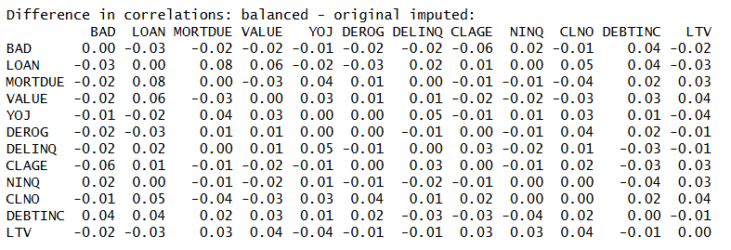
Correlation analysis was also performed on the balanced data set. The correlation results for the variables and the target variable are consistent, with slight changes in the values. This means that the balancing did not change the structure of the data.
The oversampling technique was only applied to the training set, while the test set was left unchanged. This ensures the evaluation of the model in a realistic scenario where class imbalance is a common problem.
In conclusion, the class balancing technique was effective in enhancing the minority class while preserving the original structure of the data, which can then be used to construct a reliable classifier model.
The test data also went through imputation after the training-stage imputation strategy had been selected. The output shows that all missing values in the test set were removed after imputation, which allowed the final models to score every borrower in the holdout sample.
In summary, the partitioning strategy supported model development and honest evaluation. The training data was used to learn patterns and address class imbalance, while the untouched test data was used to assess how well the final models would perform in real lending decisions.

Model Selection and Justification
The project required the use of classification, regression, and clustering. These methods were selected because each one supports a different part of the home equity loan analysis. The main business problem is to identify borrowers who may become bad borrowers, so classification is the primary modeling approach. Regression is used to study borrower leverage through LTV, and clustering is used to understand borrower segments with similar financial and credit characteristics. The requirement document also states that all three approaches are required for this project.
The model selection process was guided by the bank’s need for explainable credit decisions. Since the bank must provide clear reasons when taking adverse credit action, the selected models needed to be practical, understandable, and connected to borrower risk factors such as delinquency, derogatory reports, debt-to-income ratio, credit inquiries, job category, loan purpose, and leverage.

Clustering Model

K-means clustering was selected to group borrowers with similar credit and financial profiles. This was used as a supporting method because it does not directly predict BAD. Instead, it helps describe borrower segments in the portfolio.

The clustering approach used scaled borrower risk variables because the data included variables with very different ranges, such as loan amounts, property values, delinquency counts, and inquiry counts. Scaling was needed so that large-dollar variables would not dominate the grouping process.

Regression Models
Regression was selected to study LTV, which was created to represent loan-to-value. LTV is a numeric measure, so regression is appropriate for analyzing how borrower and loan characteristics relate to leverage. This is useful because home equity lending depends on the relationship between the loan amount and the property value.
Linear regression was selected because it gives a simple and direct way to understand relationships with LTV. And then stepwise regression was selected to help narrow the regression predictors and keep the model structure easier to explain.
Regression tree was selected because leverage patterns may not always follow a straight-line relationship. A tree can separate borrowers into groups using simple conditions and capture nonlinear relations or patterns, which keeps the analysis understandable.

Classification Models
Classification models were selected because the main target variable, BAD, is binary. A borrower is either current, shown as BAD = 0, or a bad borrower, shown as BAD = 1. Since the bank wants to identify default risk, classification is the correct modeling approach for the main credit decision problem.
Logistic regression was selected because it is suitable for a binary outcome and is easy to explain. It can show how each borrower characteristic is related to the chance of becoming a bad borrower. This fits the bank’s need for transparency because the results can be connected back to clear business factors.
Decision tree classification was selected because it creates simple decision rules. This type of model can separate borrowers using conditions based on credit history, debt burden, and borrower profile. It is useful when the bank needs a model structure that can be explained in plain language. C5.0 was selected as another classification tree method. It was included because it supports rule-based classification and gives another interpretable option for predicting BAD.

Model Fitting and Performance Evaluation
The models were fitted using the training data and evaluated on the test data to ensure that the results reflect real-world performance.

Clustering Analysis:
Clustering was used to group borrowers into segments based on similar characteristics. The goal was to identify patterns in borrower behavior and understand how risk differs across groups. This supports the business goal by helping the bank describe different types of borrowers and apply better risk strategies.
Multiple clustering approaches were tested during the analysis.
K-Means clustering with all predictors:
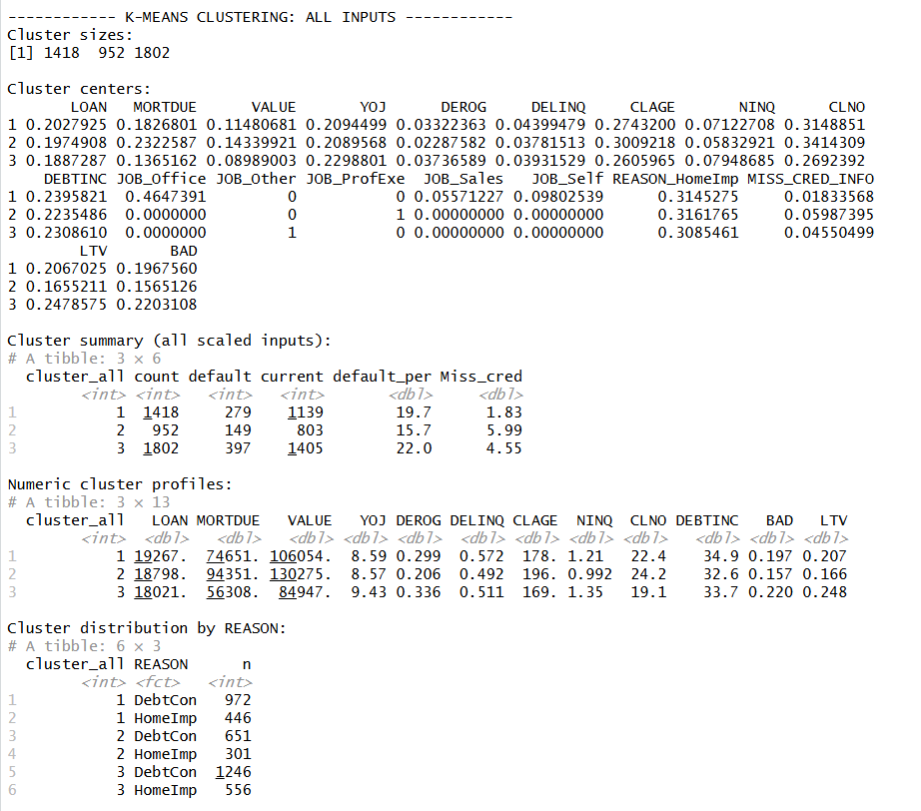

The first clustering model used all scaled inputs, including numeric borrower variables and dummy variables for JOB and REASON. This model was fitted with three clusters. The cluster sizes were 1,418, 952, and 1,802. The default rates across these groups were 19.7%, 15.7%, and 22.0%. This showed that the clustering process separated borrowers into groups with different risk levels, but the spread between the cluster default rates was moderate. Also, the clusters were influenced by categorical variables such as JOB and REASON, which made interpretation less clear. Some clusters were also dominated by specific job categories, which reduced their usefulness for general risk segmentation. The goal is risk segmentation but the use of REASON and JOB resulted in Profile segmentation.
K-means Clustering excluding JOB and REASON:

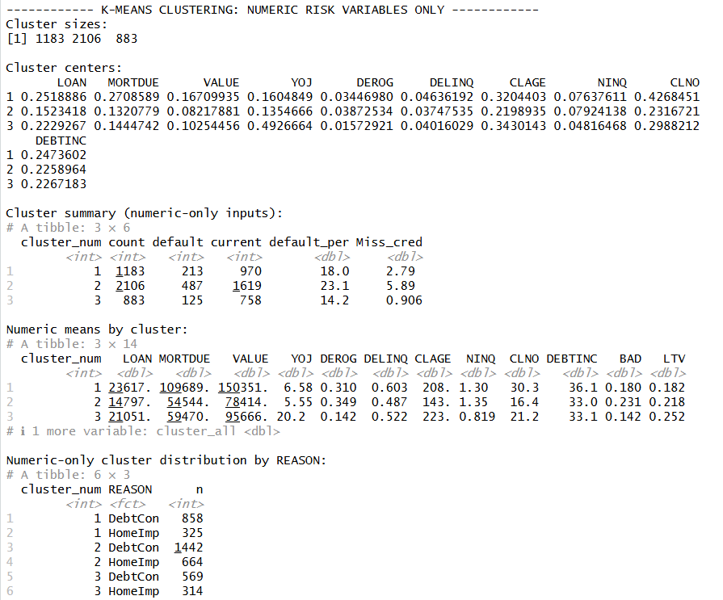
A second k-means model was fitted using only numeric risk variables. This model also used three clusters. The cluster sizes were 1,183, 2,106, and 883. The default rates were 18.0%, 23.1%, and 14.2%. This version focused only on borrower risk and financial measures, so it avoided job and reason categories from directly shaping the groups. However, it still created three groups that were somewhat overlapping. From a business perspective, having three similar groups makes it harder to clearly define risk categories and take action.
K-means Clustering with 2 clusters:
To improve clarity and usability, a two-cluster model was fitted. The number of clusters was decided by comparing average silhouette width for different k values. As shown in the below chart, the 2 cluster model has better separation than others.
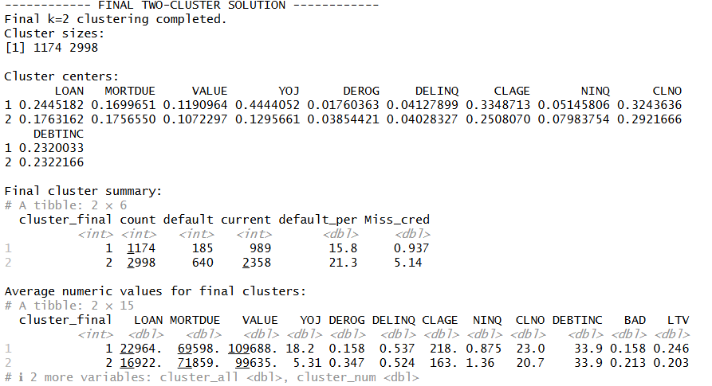
The two cluster has better segmentation compared to other with average silhouette value of 0.23. It is easier for business users to understand and apply in decision-making. Cluster 1 also had a lower missing credit information rate of 0.937%, compared with 5.14% in Cluster 2. These numbers were used to describe the borrower groups created by the clustering process.
The cluster profiles also support this interpretation. The lower-risk group has:
- Longer credit history (higher CLAGE)
- Lower derogatory marks (DEROG)
- Fewer credit issues overall
The higher-risk group shows:
- Shorter credit history
- Higher derogatory records
- Higher levels of credit risk indicators
Overall, clustering is used as a supporting analysis to understand borrower segments, while the final credit decision is based on classification models. Clustering identified differences in risk levels, although the separation between groups was moderate.

Regression Analysis:
Regression analysis was used to predict LTV (Loan-to-Value) and understand borrower leverage. The purpose of this analysis was not to predict default directly, but to study how borrower characteristics are related to financial exposure.
Full Regression Model:
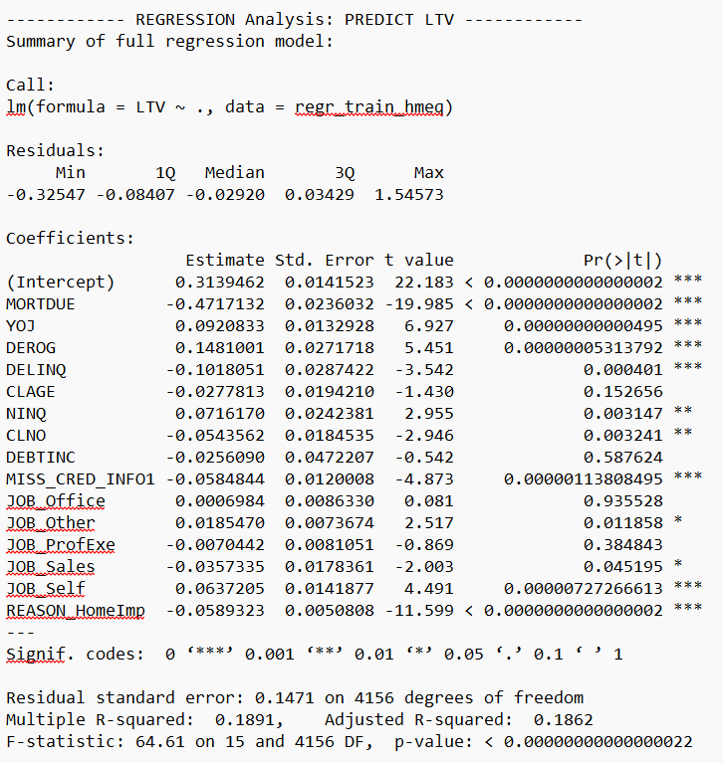
A full regression model was first developed using the available regression variables. This model produced an adjusted R-squared of 0.1891, which means it explained about 18.9% of the variation in LTV. Several variables were statistically significant, including risk MORTDUE, YOJ, DEROG, DELINQ, NINQ, CLNO, JOB_Other, JOB_Sales, JOB_Self, REASON_HomeImp, and MISS_CRED_INFO. VIF values were also reviewed, and the results did not show a serious multicollinearity problem. However, the overall explanatory power of the model was still limited.
Stepwise Regression Model:

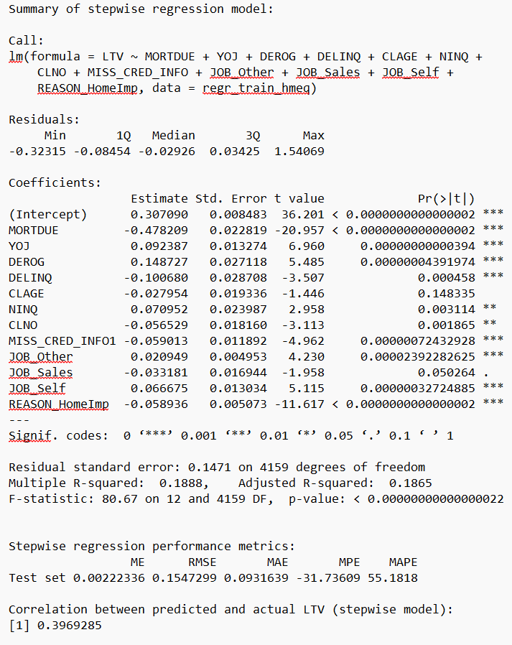
Next, a stepwise regression model was created to remove less useful variables. The stepwise model retained MORTDUE, YOJ, DEROG, DELINQ, CLAGE, NINQ, CLNO, JOB_Other, JOB_Sales, JOB_Self, REASON_HomeImp, and MISS_CRED_INFO. This model also had an adjusted R-squared of 0.1888, which was almost the same as the full model. On the test set, the stepwise model produced an RMSE of 0.1547, MAE of 0.0932, and a correlation of 0.3969 between predicted and actual LTV. This shows that stepwise variable selection did not significantly improve model performance.
Improved Regression Model:

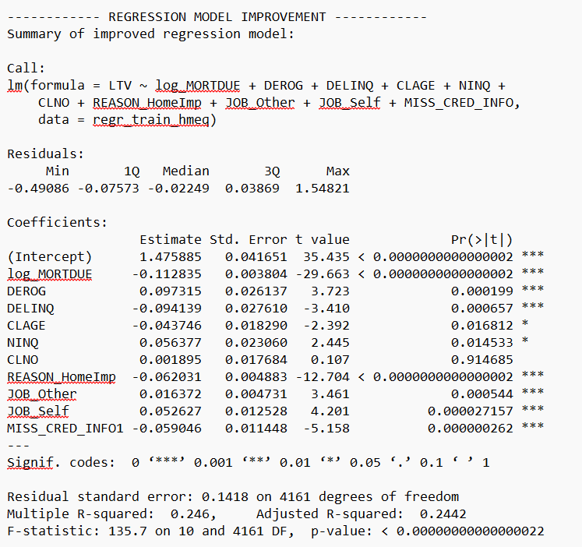
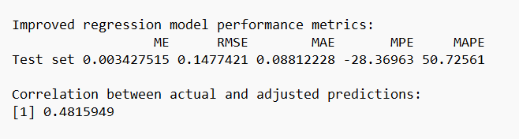
To improve the model, an enhanced regression model was then developed. In this model, MORTDUE was log-transformed and selected variables were used. The final improved model included risk_cluster, log_MORTDUE, DEROG, DELINQ, CLAGE, NINQ, CLNO, REASON_HomeImp, JOB_Other, JOB_Self, and MISS_CRED_INFO. This model performed better than the earlier models. It achieved an adjusted R-squared of 0.246, meaning it explained about 24.6% of the variation in LTV. On the test set, the improved model produced an RMSE of 0.1476, MAE of 0.0880, and a correlation of 0.4815 between actual and predicted LTV.
The improved model also produced 6 negative predictions, which were adjusted to zero because negative LTV is not meaningful. There were no predictions above 2. This adjustment made the predictions more realistic for lending interpretation.
Regression Tree:
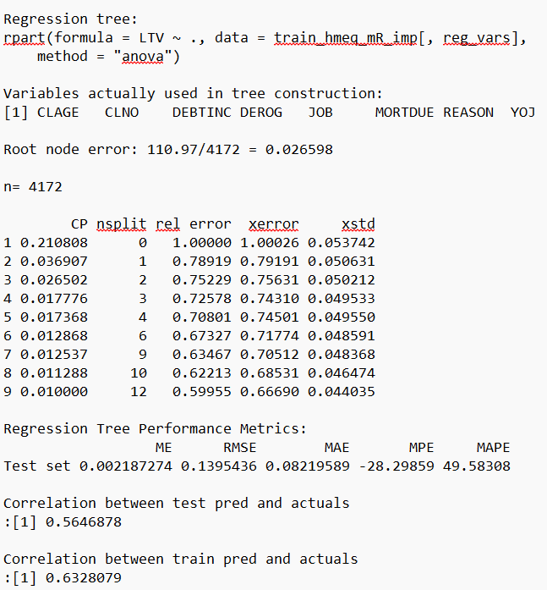
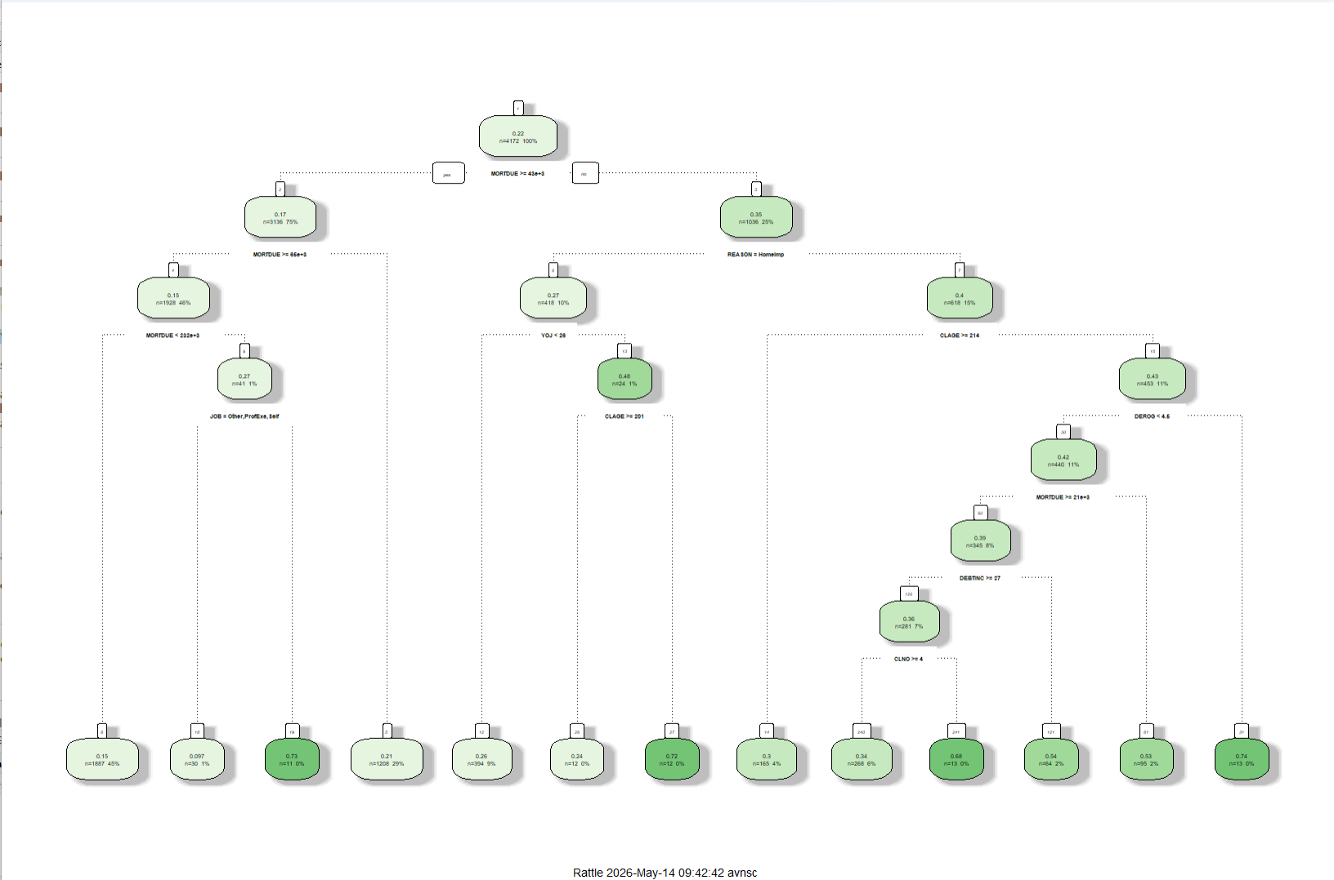
A regression tree was fitted to predict LTV using borrower and credit variables. The tree used variables such as MORTDUE, REASON, YOJ, CLAGE, DEROG, DEBTINC, CLNO, and JOB. The first split was based on MORTDUE, which means mortgage balance was the first major variable used by the tree to separate borrowers by leverage level.
The regression tree had a test RMSE of 0.1395 and MAE of 0.0822. The correlation between test predictions and actual LTV was 0.5647. The training correlation was 0.6328. The gap between training and testing correlation showed that the model fit the training data more strongly than the test data, which is expected with tree models when they create several splits
Pruned Regression Tree:
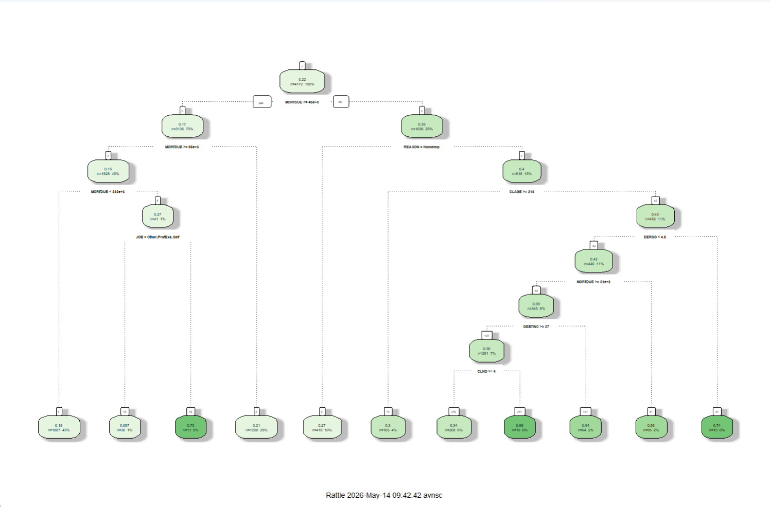
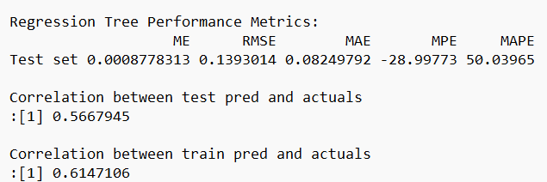
A pruned regression tree was also fitted to reduce the complexity of the original regression tree. The pruned tree used a control setting with cp = 0.012. It kept the model more compact while still using key variables such as MORTDUE, REASON, CLAGE, DEROG, DEBTINC, CLNO, and JOB.
The pruned regression tree had a test RMSE of 0.1393 and MAE of 0.0825. The correlation between test predictions and actual LTV was 0.5668, while the training correlation was 0.6147. Compared with the unpruned tree, the test RMSE was slightly lower, and the training-test correlation gap was smaller. This shows that pruning helped control tree complexity while keeping similar prediction performance. Which is important for business interpretation.

Classification of BAD:
Classification analysis was used as the main modeling approach to predict whether a borrower would become a bad borrower (BAD = 1). This directly supports the project goal because the classification models estimate default risk and can help support approve or decline decisions.
Logistic Regression Model:
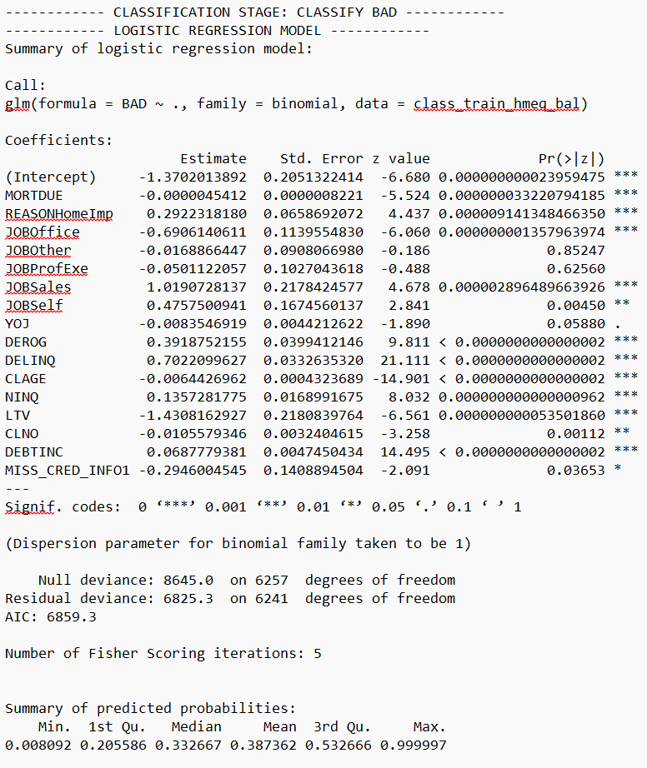
The logistic regression model was fitted on the balanced training data to predict BAD. The model used borrower credit, debt, job, loan purpose, LTV, and missing credit information variables. Important fitted predictors included DEROG, DELINQ, CLAGE, NINQ, DEBTINC, LTV, MORTDUE, JOBOffice, JOBSales, JOBSelf, REASONHomeImp, and MISS_CRED_INFO. Many of these variables had statistically significant p-values in the fitted model output.
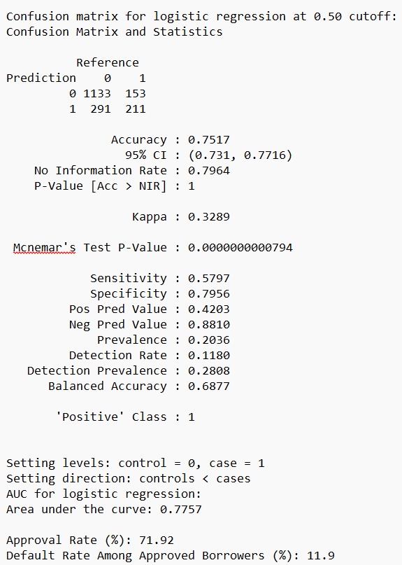
On the test data, the logistic regression model was evaluated using a 0.50 cutoff. It correctly classified 1,133 current borrowers and 211 bad borrowers. It missed 153 bad borrowers by predicting them as current and incorrectly flagged 291 current borrowers as bad. The accuracy was 0.7517, sensitivity was 0.5797, specificity was 0.7956, and balanced accuracy was 0.6877. The AUC was 0.7757, which means the model had a reasonable ability to separate bad borrowers from current borrowers using predicted probabilities.
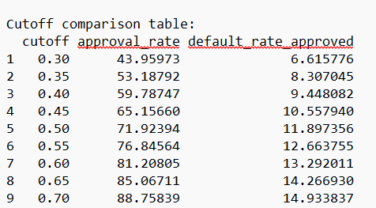
The logistic regression approval rate at the 0.50 cutoff was 71.92%. Among the borrowers approved by this cutoff, the default rate was 11.90%. The cutoff review showed that lower cutoffs reduced the approved-borrower default rate but also reduced the approval rate. For example, at a 0.30 cutoff, the approval rate was 43.96% and the default rate among approved borrowers was 6.62%. At a 0.70 cutoff, the approval rate was 88.76% and the approved-borrower default rate was 14.93%.
Decision Tree Model:
The decision tree classification model was fitted on the balanced training data. The fitted tree used borrower risk variables to split the data into current and bad borrower groups. The root node had 6,258 training records after oversampling, with 3,347 current borrower records and 2,911 bad borrower records. The first major split was based on DELINQ, which matched the earlier predictor analysis where delinquency was one of the strongest default indicators.
After pruning, the decision tree was evaluated on the test data using a 0.60 cutoff. It correctly classified 1,108 current borrowers and 238 bad borrowers. It missed 126 bad borrowers and incorrectly flagged 316 current borrowers as bad. The accuracy was 0.7528, sensitivity was 0.6538, specificity was 0.7781, and balanced accuracy was 0.7160. The AUC was 0.7625.
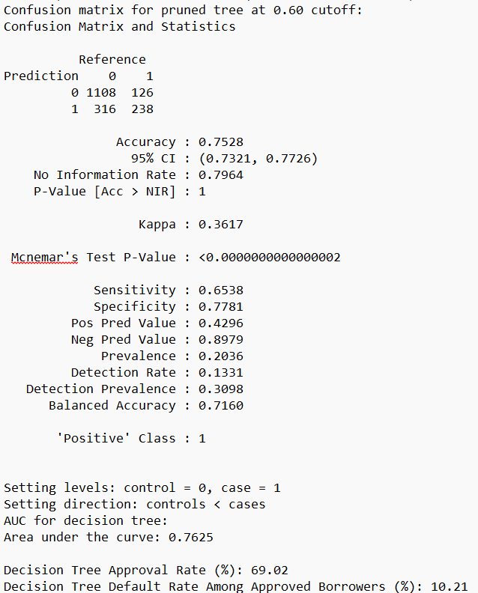
The decision tree approval rate was 69.02%, and the default rate among approved borrowers was 10.21%. These values came from the cutoff-based approval review and show how the tree’s predicted risk groups translated into lending decision rates.
The C5.0 model was fitted as another rule-based classification model for BAD. Like the decision tree, this model used borrower risk variables to classify current and bad borrowers, but it used the C5.0 algorithm to build the classification rules.
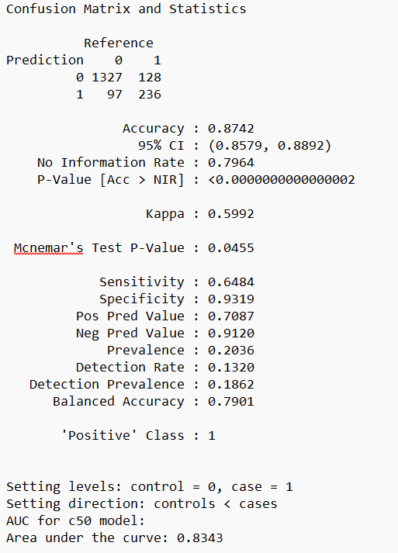
On the test data, the C5.0 model correctly classified 1,327 current borrowers and 236 bad borrowers. It missed 128 bad borrowers and incorrectly flagged 97 current borrowers as bad. The accuracy was 0.8742, sensitivity was 0.6484, specificity was 0.9319, and balanced accuracy was 0.7901. The AUC was 0.8343. The high specificity means the model was strong at identifying current borrowers, while the sensitivity shows it still missed some bad borrowers.
The cutoff review showed that the C5.0 approval rate was 81.38%, and the default rate among approved borrowers was 8.80% across the tested cutoff range. These values were used to evaluate how the model’s classifications translated into approval and risk levels.

Report on Models’ Performance
Clustering Performance
The clustering work was used to understand borrower groups in the portfolio. The first k-means model used all scaled inputs, including borrower risk variables and dummy variables for JOB and REASON. This model created three clusters with sizes of 1,418, 952, and 1,802 borrowers. The default rates were 19.7%, 15.7%, and 22.0%. This showed that the groups had different risk levels, but the difference between the lowest and highest default rates was not very large.
The second k-means model used only numeric risk variables. This model also created three clusters, with 1,183, 2,106, and 883 borrowers. The default rates were 18.0%, 23.1%, and 14.2%. This version created a clearer separation between borrower groups because the highest default group was 23.1% and the lowest was 14.2%. Since this version focused only on numeric borrower risk measures, it gave a cleaner view of credit and financial risk patterns.

The final clustering solution used two clusters. The two groups had 1,174 and 2,998 borrowers. Cluster 1 had 185 bad borrowers out of 1,174, giving a default rate of 15.8%. Cluster 2 had 640 bad borrowers out of 2,998, giving a default rate of 21.3%. The missing credit information rate was also different between the two groups, with 0.937% in Cluster 1 and 5.14% in Cluster 2. These results showed that the final two-cluster solution separated borrowers into a lower-default group and a higher-default group using borrower risk variables.
Full Linear Regression Performance
The first regression model was fitted to predict LTV. This model used all selected regression predictors. The model had a multiple R-squared of 0.1891 and an adjusted R-squared of 0.1862. This means the full model explained about 18.6% of the variation in LTV after accounting for the number of predictors.
The full model also showed that several predictors were statistically meaningful for LTV, including MORTDUE, YOJ, DEROG, DELINQ, NINQ, CLNO, MISS_CRED_INFO, JOB_Other, JOB_Sales, JOB_Self, and REASON_HomeImp. The VIF values were not very high, with the largest value around 2.57 for JOB_Other, so the model did not show a serious multicollinearity issue.
Stepwise Regression Performance
The stepwise regression model was used to reduce the regression structure while still predicting LTV. The model kept variables such as MORTDUE, YOJ, DEROG, DELINQ, CLAGE, NINQ, CLNO, MISS_CRED_INFO, JOB_Other, JOB_Sales, JOB_Self, and REASON_HomeImp.
The stepwise model had an adjusted R-squared of 0.1865. On the test data, the RMSE was 0.1547 and the MAE was 0.0932. The correlation between predicted and actual LTV was 0.3969. These values show that the model captured some of the relationship with LTV, but the prediction strength was moderate. The error values also show that the model had noticeable differences between actual and predicted leverage values.
Improved Linear Regression Performance
The improved regression model used log_MORTDUE instead of the original mortgage balance. This was done because mortgage balance was highly skewed, and the transformation helped reduce the impact of very large mortgage values.
This model had a multiple R-squared of 0.2460 and an adjusted R-squared of 0.2442. On the test data, the RMSE was 0.1477 and the MAE was 0.0881. The correlation between actual and adjusted predicted LTV values was 0.4816. Compared with the stepwise regression model, the improved model explained more variation in LTV and had lower prediction error. The output also showed 5 negative predictions, which were adjusted to 0 because negative loan-to-value values are not meaningful in lending. There were no predictions above 2.
Regression Tree Performance
The regression tree was also fitted to predict LTV. This model used rule-based splits instead of a straight-line relationship. The first split was based on MORTDUE, which showed that mortgage balance was the most important first separator for leverage in the tree structure.
The regression tree had a test RMSE of 0.1395 and MAE of 0.0822. The correlation between test predictions and actual LTV was 0.5647. The training correlation was 0.6328. This means the tree captured the training data more strongly than the test data, which is common for tree models when they create detailed splits.
Pruned Regression Tree Performance
The pruned regression tree was fitted to reduce the complexity of the original regression tree. It kept the main decision structure while removing some extra splits.
The pruned regression tree had a test RMSE of 0.1393 and MAE of 0.0825. The test correlation was 0.5668, and the training correlation was 0.6147. Compared with the unpruned tree, the test RMSE was slightly lower, and the gap between training and testing correlation was smaller. This showed that pruning helped simplify the tree while keeping the prediction performance almost the same.
Logistic Regression Performance
The logistic regression model was fitted to predict BAD using the balanced training data. Several predictors were meaningful in the model output, including MORTDUE, REASONHomeImp, JOBOffice, JOBSales, JOBSelf, DEROG, DELINQ, CLAGE, NINQ, LTV, CLNO, DEBTINC, and MISS_CRED_INFO.
At the 0.50 cutoff, the model correctly classified 1,133 current borrowers and 211 bad borrowers. It incorrectly classified 291 current borrowers as bad and missed 153 bad borrowers. The accuracy was 0.7517, sensitivity was 0.5797, specificity was 0.7956, and balanced accuracy was 0.6877. The AUC was 0.7757. These values show that the model had a reasonable ability to separate current borrowers from bad borrowers, but it identified current borrowers more strongly than bad borrowers.
The approval rate at the 0.50 cutoff was 71.92%. Among approved borrowers, the default rate was 11.90%. The cutoff review showed the trade-off between approval rate and default rate. At a 0.30 cutoff, the approval rate was lower at 43.96%, but the default rate among approved borrowers was also lower at 6.62%. At a 0.70 cutoff, the approval rate increased to 88.76%, but the default rate among approved borrowers increased to 14.93%.
Decision Tree Classification Performance
The decision tree classification model was fitted on the balanced training data and then pruned before testing. The tree used variables such as DELINQ, CLAGE, DEBTINC, DEROG, LTV, CLNO, and MORTDUE in the splitting process. The first major split was based on DELINQ, which matched the earlier risk pattern where delinquent credit lines were strongly related to default.
At the 0.60 cutoff, the pruned decision tree correctly classified 1,108 current borrowers and 238 bad borrowers. It incorrectly classified 316 current borrowers as bad and missed 126 bad borrowers. The accuracy was 0.7528, sensitivity was 0.6538, specificity was 0.7781, and balanced accuracy was 0.7160. The AUC was 0.7625. Compared with logistic regression, this model identified more bad borrowers, but it also flagged more current borrowers as bad.
The decision tree approval rate was 69.02%, and the default rate among approved borrowers was 10.21%. This means the model approved a smaller share of borrowers than logistic regression at its 0.50 cutoff, but the default rate among approved borrowers was also lower.
C5.0 Classification Performance
The C5.0 model was fitted as another tree-based classification model. It used borrower risk variables such as MORTDUE, YOJ, DEROG, LTV, DELINQ, CLAGE, NINQ, CLNO, and DEBTINC.
At the 0.60 cutoff, the C5.0 model correctly classified 1,327 current borrowers and 236 bad borrowers. It incorrectly classified 97 current borrowers as bad and missed 128 bad borrowers. The accuracy was 0.8742, sensitivity was 0.6484, specificity was 0.9319, and balanced accuracy was 0.7901. The AUC was 0.8343. These numbers show that C5.0 had strong overall classification performance, especially in correctly identifying current borrowers.
The C5.0 approval rate was 81.38%, and the default rate among approved borrowers was 8.80%. In the cutoff comparison output, this approval rate and approved-borrower default rate stayed the same across the tested cutoff values from 0.30 to 0.70.

Report on Comparison and Evaluation of Selected Models

Clustering Analysis
Three clustering approaches were compared in this project. The first k-means model used all scaled inputs, including numeric variables and dummy variables for JOB and REASON. This model created three clusters with sizes of 1,418, 952, and 1,802. The default rates were 19.7%, 15.7%, and 22.0%. This model separated borrowers partly by job and loan reason, but the difference in default rates between the clusters was not very wide.
The second k-means model used only numeric risk variables. It created three clusters with sizes of 1,183, 2,106, and 883. The default rates were 18.0%, 23.1%, and 14.2%. This version gave a clearer risk separation than the all-input model because the groups were formed using direct financial and credit variables such as LOAN, MORTDUE, VALUE, YOJ, DEROG, DELINQ, CLAGE, NINQ, CLNO, and DEBTINC.
The final clustering model used two clusters based on numeric risk variables. This model created one group with 1,174 borrowers and another group with 2,998 borrowers. Cluster 1 had a default rate of 15.8%, while Cluster 2 had a default rate of 21.3%. Cluster 2 also had a higher missing credit information rate at 5.14%, compared with only 0.937% in Cluster 1.
The selected clustering solution is the final two-cluster model. This model is easier to explain to the bank because it separates borrowers into two clear portfolio groups: a lower-risk borrower segment and a higher-risk borrower segment. It is also more practical than a three-cluster solution because the difference between the two groups is simple to communicate. From a business point of view, this clustering result helps the bank understand that borrowers with shorter job history, more derogatory records, more recent inquiries, and more missing credit information are more concentrated in the higher-default segment.

Regression Analysis
The regression models were compared using LTV as the target variable. The stepwise regression model had an adjusted R-squared of 0.1865, RMSE of 0.1547, MAE of 0.0932, and prediction correlation of 0.3969. This model was easy to explain, but its prediction strength was moderate.
The improved regression model performed better than the stepwise model. It used log_MORTDUE to reduce the effect of large mortgage values. Its adjusted R-squared increased to 0.2442, RMSE decreased to 0.1477, MAE decreased to 0.0881, and prediction correlation improved to 0.4816. This showed that the transformation helped the regression model better explain loan-to-value behavior.
The regression tree model performed stronger than the linear regression models. It had an RMSE of 0.1395, MAE of 0.0822, and test correlation of 0.5647. The pruned regression tree performed slightly better, with an RMSE of 0.1393, MAE of 0.0825, and test correlation of 0.5668. The pruned tree also had a lower training correlation than the full tree, 0.6147 compared with 0.6328, which means it reduced some model complexity while keeping strong test performance.
The selected regression model is the pruned regression tree. It is selected because it gave the strongest test correlation and the lowest RMSE among the regression models, while still keeping the model structure easier to explain than a larger tree. In business terms, this model helps explain borrower leverage patterns using clear borrower conditions. The tree showed that MORTDUE was the first major split, meaning existing mortgage balance played an important role in separating borrowers by loan-to-value level. This supports the home equity loan goal because leverage is directly tied to collateral exposure and loan risk.

Classification Analysis
The classification models were compared because predicting BAD is the main credit risk goal of the project. Logistic regression, decision tree, and C5.0 were evaluated on the test data.
The logistic regression model had an accuracy of 0.7517, sensitivity of 0.5797, specificity of 0.7956, balanced accuracy of 0.6877, and AUC of 0.7757. At the 0.50 cutoff, it approved 71.92% of borrowers, and the default rate among approved borrowers was 11.90%. This model was easy to explain, but it missed more bad borrowers than the tree-based models.
The pruned decision tree had an accuracy of 0.7528, sensitivity of 0.6538, specificity of 0.7781, balanced accuracy of 0.7160, and AUC of 0.7625. It approved 69.02% of borrowers, and the default rate among approved borrowers was 10.21%. Compared with logistic regression, it identified more bad borrowers and reduced the default rate among approved borrowers, but it also rejected more current borrowers.
The C5.0 model had the strongest overall classification performance. It had an accuracy of 0.8742, sensitivity of 0.6484, specificity of 0.9319, balanced accuracy of 0.7901, and AUC of 0.8343. It approved 81.38% of borrowers, and the default rate among approved borrowers was 8.80%. This means it gave the strongest balance between approving borrowers and controlling default risk among the reported classification models.
The selected classification model is C5.0. It is selected because it had the highest accuracy, highest specificity, highest balanced accuracy, highest AUC, and lowest default rate among approved borrowers. It also approved a larger share of borrowers than logistic regression and decision tree while keeping the approved-borrower default rate lower. From a business point of view, this supports the bank’s goal of reducing credit risk without being overly restrictive on loan approvals.
The C5.0 model is also useful because it is a rule-based classification method. This supports the bank’s need for explainable decisions. The main business interpretation is that borrower credit behavior and debt pressure are important for separating current borrowers from bad borrowers. Variables such as DELINQ, DEROG, CLAGE, NINQ, DEBTINC, LTV, and MORTDUE help the bank understand risk in practical terms. This makes the selected classification model useful for supporting consistent and defensible credit decisions.
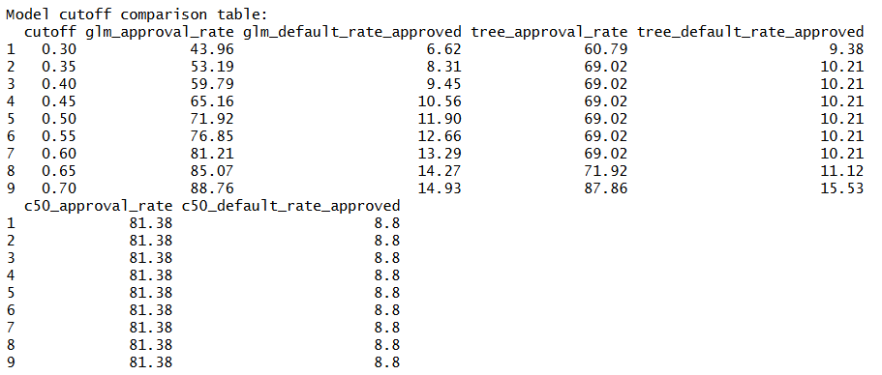
The cutoff comparison shows how the bank can adjust the approval decision based on its risk tolerance and loan growth goals. For logistic regression, a lower cutoff is more conservative: at 0.30, the approval rate is only 43.96%, but the default rate among approved borrowers is also low at 6.62%. As the cutoff increases, more borrowers are approved, but the approved-borrower default rate also increases. For example, at 0.70, the logistic model approves 88.76% of borrowers, but the default rate among approved borrowers rises to 14.93%. The decision tree shows a similar pattern, although its approval rate stays at 69.02% for several cutoff values and then increases at higher cutoffs. The C5.0 model is more stable across all tested cutoffs, with an approval rate of 81.38% and an approved-borrower default rate of 8.80%.

Report on Observations and Conclusions
This analysis shows that the bank requires a more standardized and data-driven process for home equity loans. Besides reducing the number of defaults, the business problem for the bank also included avoiding the adoption of a process that is too strict as it may hinder growth. The project requirement further shows that the bank needs to justify its credit decisions since the decision should have specific reasons, according to the ECOA.
In analyzing the data for the bank, one conclusion that can be drawn is that the credit behavior of the borrowers provides the most information on the risk of default. The delinquent credit lines, derogatory credit reports, debt to income ratio, recent credit inquiries, and credit history all provided more detailed information about the risk than just the loan amount. It is helpful because these variables are easy to interpret.
The exploration showed that delinquency history is one of the clearest warning signs. Borrowers with no delinquent credit lines had a much lower bad borrower rate, while the bad borrower rate increased as delinquent credit lines increased. This tells the bank that recent repayment problems should receive strong attention in the credit decision process.
Derogatory credit reports also showed a clear risk pattern. Borrowers with more derogatory records were more likely to become bad borrowers. This supports the bank’s need for a standardized score because this kind of credit history can be evaluated consistently instead of depending too much on individual underwriter judgment.
Debt-to-income ratio was also an important business factor. A higher debt burden means the borrower may have less ability to handle additional loan payments. This helps the bank evaluate repayment capacity in a way that is directly related to lending risk.
Credit history also gave useful information. Borrowers with longer credit histories were generally less risky. This makes business sense because longer credit history gives the bank more evidence about the borrower’s repayment behavior.
Clustering outcomes help the bank understand that risk is not evenly distributed across the portfolio. Some borrower segments may need standard review, while others may need closer monitoring or stronger policy attention. This supports the business goal of improving consistency because the bank can use borrower segments to guide portfolio review instead of relying only on individual judgment.
Clustering should not be used as the final approval or decline decision. Its main value is business insight. It helps management understand borrower groups, monitor risk concentration, and identify where policy changes may be needed.
The Regression analysis is useful because the bank’s credit decision is not only about whether a borrower may default. It is also about how much exposure the bank has if the borrower does default. A borrower with higher leverage may create more concern because there is less equity cushion behind the loan.
The regression outcome supports the business goal by giving the bank a clearer view of financial exposure. It helps the bank understand which borrower and loan characteristics are connected with leverage. This can support better policy review, collateral assessment, and risk-based underwriting.
The selected classification approach supports the business goal because it uses clear borrower information such as delinquency history, derogatory reports, debt-to-income ratio, recent inquiries, credit history length, mortgage balance, job category, loan reason, and leverage. These are practical credit factors that the bank can explain to business users, underwriters, and compliance reviewers.
This outcome helps reduce inconsistency in the current process. Instead of different underwriters applying judgment differently in borderline cases, the bank can use a structured model to evaluate borrowers more consistently. This supports faster decisions and helps the bank remain competitive with lenders that offer quicker loan decisions.
The cutoff comparison can help the bank choose a cutoff that balances risk reduction and loan growth. If the bank wants to be very conservative, it can choose a lower cutoff to reduce defaults but approve fewer loans. If the bank wants to support growth, it can choose a higher cutoff, but it must accept a higher default rate. Based on this cutoff review, C5.0 provides a practical balance because it keeps approvals relatively high while keeping the default rate among approved borrowers lower than the other models at similar approval levels.
Final Conclusion:
The classification outcome also supports ECOA-related transparency. Since the model relies on understandable borrower and credit variables, the bank can connect risk decisions to specific factors. This is important because the project requirement states that adverse decisions must be supported by clear and defensible reasons.
The analysis shows that the bank can improve its home equity loan process by using a structured credit scoring framework. The main risk drivers are not just loan size or property value. The strongest signals come from borrower credit behavior, debt burden, recent credit activity, and credit history strength.
The clustering outcome helps the bank understand borrower segments in the portfolio. The regression outcome helps explain leverage and collateral exposure. The classification outcome supports the main decision process by identifying borrowers who are more likely to become bad borrowers.
Together, these outcomes support the bank’s business goal of reducing credit risk while maintaining loan growth. The solution helps standardize decisions, reduce dependence on inconsistent manual judgment, improve operational efficiency, and provide clearer reasons for credit decisions. This makes the analysis useful as a decision-support framework for a modern home equity lending process.

